**OFFICIAL COORDINATION REQUEST FOR**

**NON-ROUTINE OPERATIONS AND MAINTENANCE**

**COORDINATION TITLE- 23BON24 MOC Old Navlock dredge placement**

**COORDINATION DATE- 31 May 2023**

**PROJECT- Bonneville Lock and Dam**

**RESPONSE DATE- 14 Jun 2023**

**Description of the problem -** The Corps is proposing to install new concrete stoplogs across the upstream entrance of Bonneville Dam NavLock 1 (NL1), and into the existing stoplog slots. NL1 has been inactive since the 1990s, and the stoplogs will be used to dewater NL1 so inspections / maintenance can occur. The new stoplogs will be installed via barge and no mods to existing staging areas or access routes will be needed. Prior to installation, dredging is required of approximately 1600 CYs of accumulated sediment at the NL1 upstream sill to allow for watertight placement of the new stoplogs. The dredged material is proposed for in water disposal downstream of the dam via barge in the active flow areas at Columbia River flow lane RM 144. Comprehensive sediment testing has been accomplished and material has been approved as suitable for in water disposal by ODEQ and USEPA reps via the Portland Sediment Evaluation Team (PSET) process on 22 Feb 2023. Proponent requests dredging and in water deposition of ~1600 CYs (PSET tested suitable for in water placement) sediment for Bon Navigation Lock 1 inspections and maintenance.

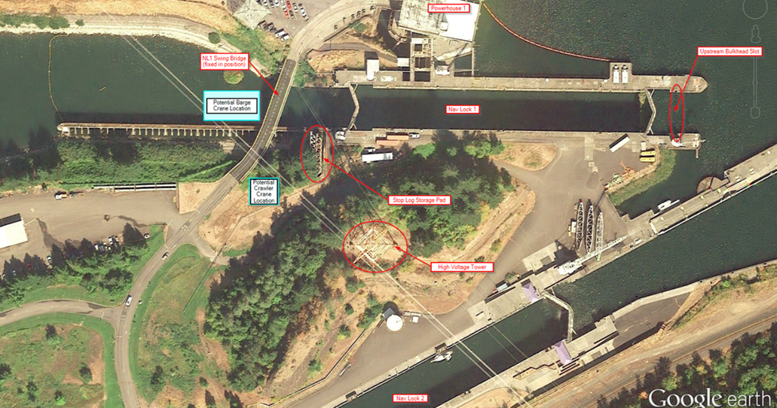

**Figure 1-1 Bon Dam Project area with NL1 Upstream Bulkhead slot (site of dredge action) at far right**

**Type of outage required-** None

**Impact on facility operation-** None, no impacts to Bonneville Dam or Fish Passage Operations, NL1 is currently not in use.

**Dates of impacts/repairs-** Work planned for Bonneville dam In Water Work Windows,Jan 14-31, 2024.

**Length of time for repairs-** 1-2 weeks total for mobilization, dredging of NL1 concrete sill/apron (~1600 CYs), and downriver transport and placement (Columbia River flowlane RM 144).

**Analysis of potential impacts to fish-**

This work is scheduled to occur during the normal winter maintenance period. There should be minimal impacts to fish.

**Summary statement** –

Expected impacts on any fish species are minimal (from dredging action at Bonneville NL1 as well as in water deposition of sediment in Columbia River Flowlane at RM 144), due to work being conducted within Bonneville Dam in water work window (Nov-Feb) and historically documented reduced fish passage on Columbia River at Bonneville during that time. In addition, current BON Ops plan for IWW 2023/2024 is for a complete shutdown of fish passages for scheduled maintenance during the 2023/2024 IWW window, further reducing any expected impacts to listed species. However, some minor species impacts are expected during actual dredge operations as Larval/Juvenile Lamprey may be disturbed while sediment is removed via dredge suction device or mechanical clamshell dredge. Dredging contractor will be advised to check dredge sediment periodically and document any fish species encountered and attempt to return same to water column immediately upon discovery with as minimal handling as practicable.

The proposed action (maintenance dredging at BON NL1 upstream concrete apron) is in line with O&M activities as found “not likely to jeopardize” protected anadromous fish spp. and “will not destroy or adversely modify designated critical habitat for the same species” per 2020 NMFS Biological Opinion for Continued Operation and Maintenance of the Columbia River System, Sections 1.3.1.5 (Operations for Navigation) and 1.3.1.7 (System Maintenance). In addition, a minimal Environmental Remediation benefit is expected to be realized from retention of the sediment material in the Columbia River flowlane as the natural channel flow transports the sediment as nourishing materials for downstream wetland replenishment in place of deposits that naturally erode away due to wave action, wind, etc.

**Expected impacts**

**Downstream migrants:** Juvenile salmonid minor impacts only expected due to historic salmonid run periods are outside proposed work window (BON IWW Dec-Feb).

**Upstream migrants (including Bull Trout):** Adult passage, including bull trout, minor impacts only expected due to historic salmonid run periods are outside proposed work window (BON IWW Dec-Feb).

**Lamprey:** Juvenile/larval lamprey may be disturbed/collected/injured via limited dredging action. Contractor to be advised to mitigate impacts via management practices

**Comments from agencies:**

**Yakama Nation -** -----Original Message-----  
From: Ralph Lampman <lamr@yakamafish-nsn.gov>   
Sent: Saturday, June 03, 2023 6:26 AM  
To: Mackey, Tammy M CIV USARMY CENWP (USA) <Tammy.M.Mackey@usace.army.mil>  
Subject: [URL Verdict: Neutral][Non-DoD Source] Re: FPOM: Official Coordination - 23BON24 MOC Old navlock dredge placement

Hi Tammy,

What specifically are the "management practices" that are mentioned below?

Lamprey: Juvenile/larval lamprey may be disturbed/collected/injured via limited

dredging action. Contractor to be advised to mitigate impacts via management practices

I have heard quite a few (hundreds of juvenile lamprey) have been found here in the past and would be important to make a concerted effort to both rescue them as well as document them (subsample some for life stage [larva vs. juveniles], genetics, etc. to find out where the source of these lamprey(s) are).

~Warm Regards~

Ralph Lampman

COLUMBIA RIVER| Honor. Protect. Restore

Yakama Nation FRMP, Pacific Lamprey Project

[lamr@yakamafish-nsn.gov](mailto:lamr@yakamafish-nsn.gov) <<mailto:lamr@yakamafish-nsn.gov>>

509-388-3871

<Blockedhttps://ci3.googleusercontent.com/mail-sig/AIorK4ym0GVt_-m9okcUg1HieaIBWhFGPGf_mlBDopkd0rAb3zadzuuiwV64iw8BC-cK8aP_73afBY4>

**Final coordination results:**

Please email or call with questions or concerns.

Thank you,

Tammy Mackey

Columbia River Coordinator

503-808-4318

[Tammy.m.mackey@usace.army.mil](mailto:Tammy.m.mackey@usace.army.mil)

**J Barry Moncrief, Portland District Env Resource Specialist**

Env Resources Branch

Phone: 503-808-5101

Email: [james.b.moncrief@usace.army.mil](mailto:james.b.moncrief@usace.army.mil)

David Griffith

Endangered Species Act Coordinator

USACE Portland District

(503) 808-4773

Email: [David.W.Griffith@usace.army.mil](mailto:David.W.Griffith@usace.army.mil)